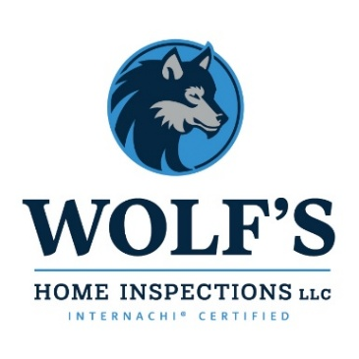
(785)220-7590
info@wolfshomeisp.com

Wolf’s Home Inspections Pricing
Whole Home up to 2500 sqft… $499
Whole Home up to 3500 sqft… $549
Whole Home up to 4500 sqft… $599
Whole Home 5500 sqft+… $699

Whole Home/Termite up to 2500 sqft…​ $575
Whole Home/Termite up to 3500 sqft … $625
Whole Home/Termite up to 4500 sqft…​ $725
Whole Home/Termite 5500 sqft​+… $825

Whole Home/Termite/Radon up to 2500 sqft… $729
Whole Home/Termite/Radon up to 3500 sqft … $799
Whole Home/Termite/Radon up to 4500 sqft​… $899
Whole Home/Termite/Radon 5500 sqft+… $999

Termite… $149
Radon… $199
Mold… $299 + $30 Per Additional Sampling
Crawlspace Access… $99
Outbuilding W/O HVAC… $99
Outbuilding With HVAC… $149
Water Intrusion up to 2500 sqft… $199
Water Intrusion up to 3500 sqft… $249
Water Intrusion up to 4500 sqft… $349
Water Intrusion up to 5500 sqft… $449

4-Stage New Construction Draw… Starting at $1499

